auburn university school of architecture
the rural studio

perry county learning center

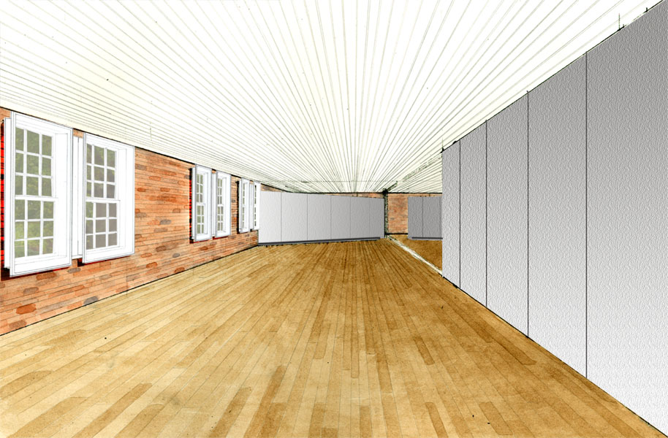
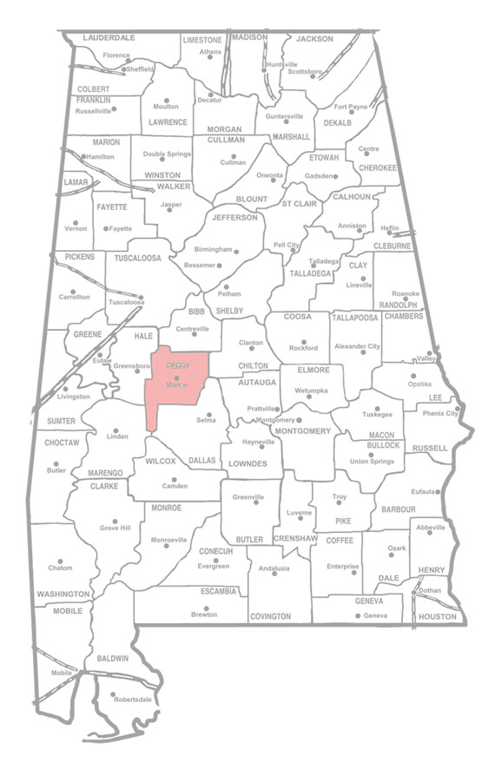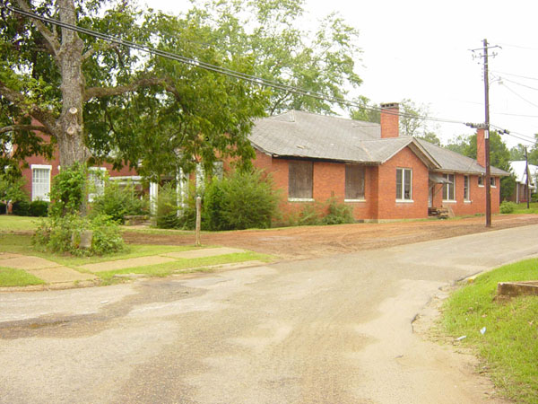
project history

southeast view
The Perry County School System consists of Uniontown Elementary School and R.C. Hatch High School of Uniontown, Alabama as well as Albert Turner Elementary School and Francis Marion High School of Marion, Alabama.

These four schools carry out the typical duties as disciplinarians by placing habitually disobedient children in Alternative School. This setting isolates the students, depriving them of the opportunity to disrupt their fellow classmates. In 1999, the Perry County Alternative School was badly burned by arson. After this event occurred, the board of education had no other choice but to send the unruly students home, where a larger dilemma faced the community.

The Former Mayor of Marion, Ed Daniel, approached the current superintendent of the Perry County School System, John Heard, and introduced him to the Rural Studio and the progress that has been made at the Perry Lakes Park.

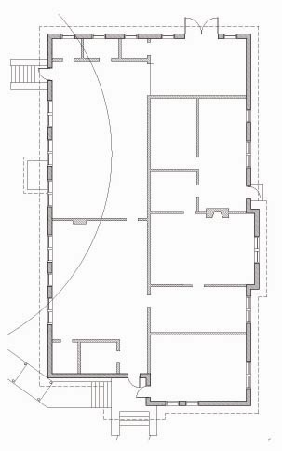
existing plan

page 2

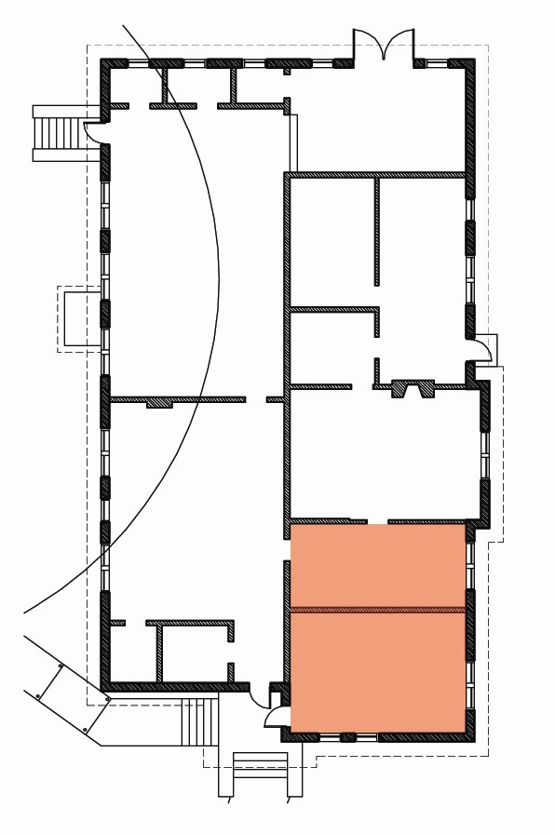
This introduction began a conversation between Mr. Heard and thesis professor Andrew Freear. This discussion ultimately led to the addition of the old Perry County Alternative School Building as a 2004-2005 Rural Studio Thesis Project.

Operating in the poorest county in Alabama, ($11,000 per capita income), the Perry County School System faces a daily battle to provide their students with the best educational opportunities. As a client of the Rural Studio, the design and labor will be provided at no charge, while the cost of materials will be covered by a minimally proposed budget, as well as project-specific donations.

In conjunction with a client panel representing the Perry County School System, a thesis student team will design and build a new alternative school to occupy and revitalize the old Perry County Alternative School building.

burned portion of building

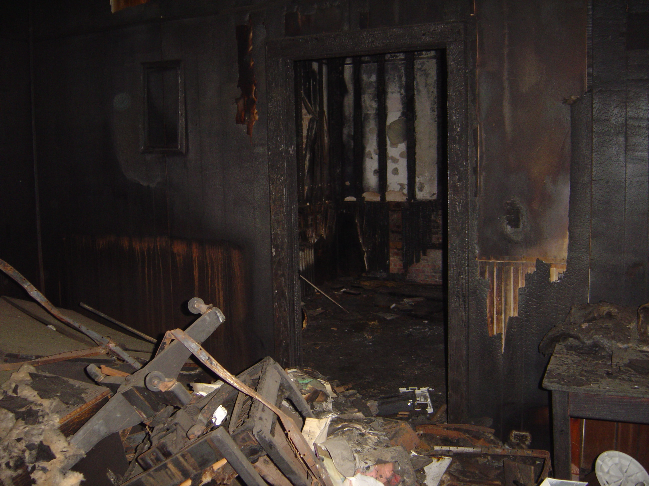
design
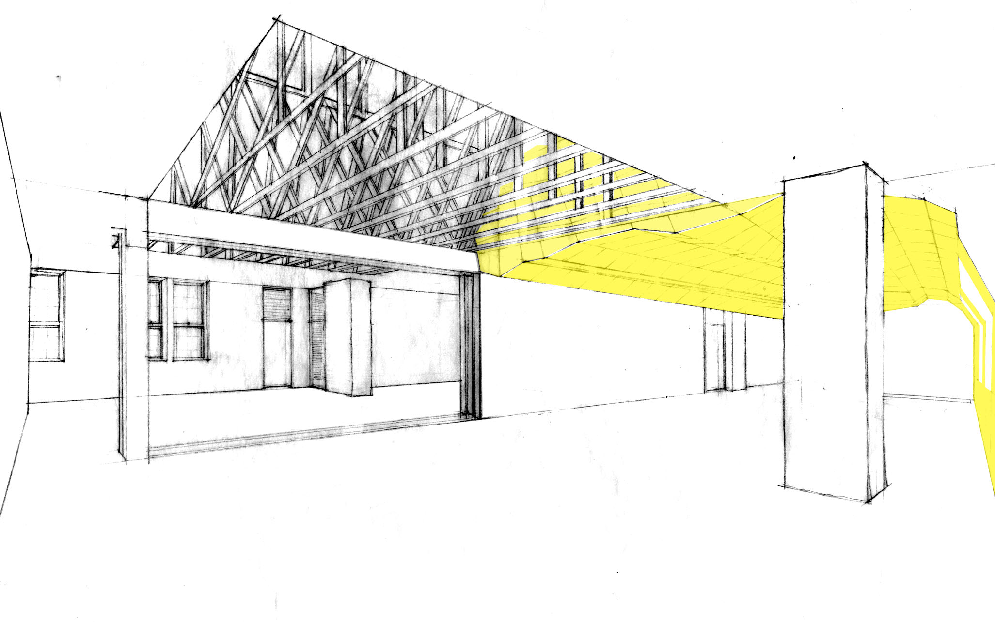
The design focus for the Perry County Learning Center was derived from the needs of our client, the Perry County School System. Superintendent Heard originally requested that a space be created and refurbished to accommodate a new alternative school. Mr. Heard also expressed interest in this building possibly functioning as a Teacher Resource Center at some future date. After extensively researching how alternative schools and resource centers function as well as closely examining the possibilities of our building, we determined that this building could serve our client as an Alternative School and a Teacher Resource Center simultaneously.

In addition to providing our client with the most useful and flexible plan arrangement possible, we are also sensitive to their financial constraints. As such, perhaps our single greatest design concept is the way our building performs in terms of energy efficiency.
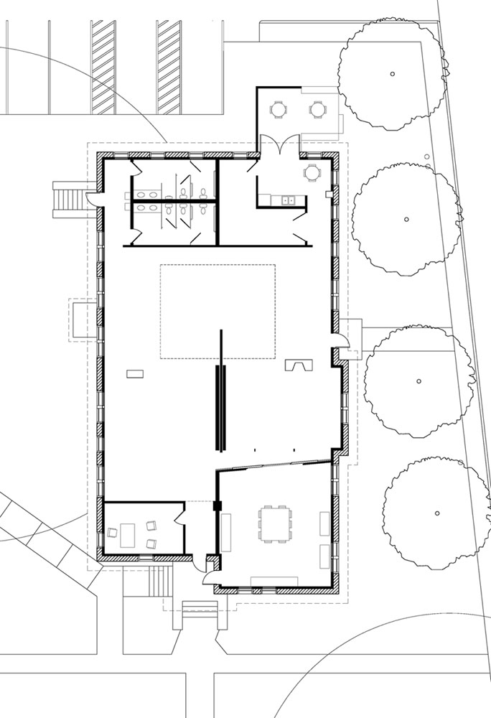
proposed plan

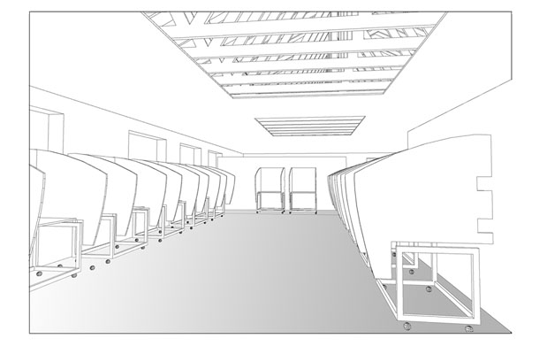
The Perry County Learning Center will not only be a great asset to the Perry County School System, it will also serve as an example of how an old building can be reused efficiently and beautifully. This project will strive for sustainability by reusing the existing building and all materials of value, as well as pursuing methods to reduce energy usage.

The exterior of the building will primarily be authentically restored with the exception of a few elements that subtly signify the transformation the building has undergone. The interior of the Perry County Learning Center will be spatially, visually and acoustically divided to a large degree with the use of floor, ceiling, and material changes rather than walls. These spaces will be naturally lit and ventilated in order to minimize the heating, cooling, and lighting costs.

`

page 4
alternative school
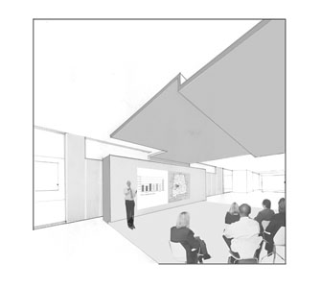
small presentation space
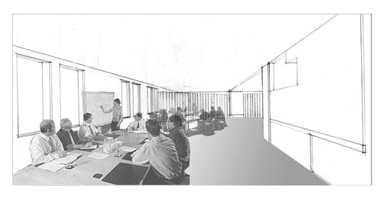
teacher in-service meetings
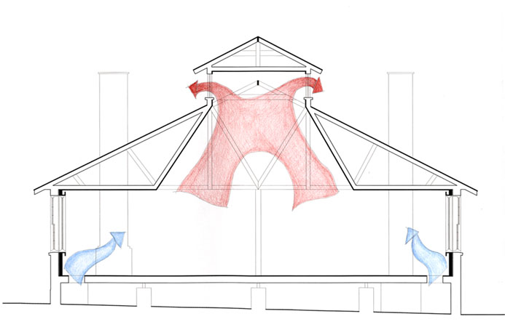
cross section
page 5
proposal
As an architecture program, the Rural Studio has received wide acclaim. Sources ranging from “Architectural Record” magazine to the Building Museum in Washington D.C. have recognized the outstanding contributions the Rural Studio has made to West Alabama as well as the architectural community.

As an educational and charitable organization, the Rural Studio operates primarily through grants and donated materials. The students at the Rural Studio work under the demand of providing the highest quality design at the absolute minimum cost. We have had great success in the past partnering with various manufacturers to obtain surplus, donated, discounted, and recycled materials. In return, we offer these manufacturers links on our website, use of project photographs, and business deductions for the value of donated materials. More importantly, we offer manufacturers from across the country the opportunity to change peoples’ lives. It is only due to their generosity that we have been able to serve this area for over 10 years. We hope that you will consider partnering with the Rural Studio to make the Perry County Learning Center a success, thereby making an immeasurable contribution to the educators, children, and families of one of the poorest counties in Alabama.

Page 6

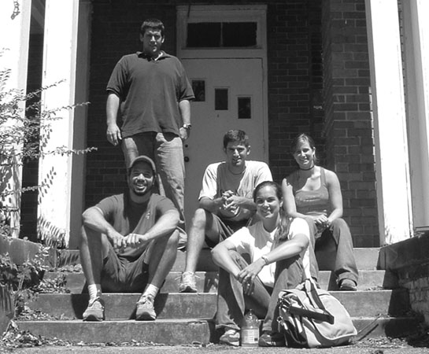

Dereck Aplin Slocomb, AL
Amy Bell Dothan, AL
Sam Currie Pensacola, FL
Angela Hughey Montgomery, AL
Turnley Smith Florence, AL

